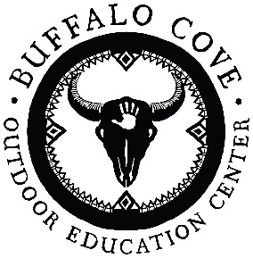
Wednesday Adventure Program
Camper Registration
Spring 2021: April 21, 28 and May19

Camper Name: ______________________________________________________________________
First Middle Last

Age at Arrival to Camp: _______ Current Grade: _______ Date of Birth: _____/_____/______

Gender Identity ______ Return Camper? Yes ___ No _____

Parent/Guardian Names: _____________________________________________________________
_________________________________________________________________________________

Address_____________________________________________________________________

City ________________________________ State __________ Zip _____________________

E-Mail: _____________________________________________________________________

Is E-mail a good way to communicate w/you? ________

Phone #: home -__________________work - _________________cell -__________________

I grant permission for my child to participate in all Fall Adventure Camp activities. I fully understand that my child will be learning to use fire & sharp tools, including pocketknives, in order to learn certain skills. They will be hiking, swimming, canoeing, and playing in a rough wilderness environment. I fully understand that Buffalo Cove employees may be transporting my child, in a motorized vehicle. I fully understand that certain accidents may occur and that there is no guarantee of safety from COVID & I agree not to hold Buffalo Cove Outdoor Education Center, its board members, owners, directors, or staff liable in any way, whatsoever.

Signature: ______________________________________

Please share your child’s interests and preferred activities with us:
____________________________________________________________________________________

How did you learn about Buffalo Cove? __________________________________________

Payment Details: YOU ARE COMMITTING TO ALL 3 PROGRAM DAYS. WE CAN NOT GRANT REFUNDS FOR MISSED DAYS WITH THIS PROGRAM. Please return this Registration with the $300 fee (payments can be set up). Upon receipt of your Registration and Payment, we will send you additional paperwork with program logistics, forms and details. All paperwork and final payments must be received no later than April 12th.

Please make all checks payable to:
Buffalo Cove Outdoor Education Center
664 Buckskin Hollow. Deep Gap, NC 28618
828 964 1473
www.buffalocove.com
e-mail: programs@buffalocove.com

